|  |  |  |
| --- | --- | --- |
|  | | |
| **VRoom**  **Virtual Meeting Room Service**  Software Requirement Specification | | |
| 2021.10.31. | | |
| **Introduction to Software Engineering 41**  **Team 2** | | |
|  | Team Leader | Kim Jinwoong |
| Team Member | Hong Seongjun |
| Team Member | Kim Hongbeen |
| Team Member | Kim Minhee |
| Team Member | Lee Hyewon |
| Team Member | Lee Jiwoo |
| Team Member | Seo Chaeyeon |

**CONTENTS**

1. Introduction 7

1.1. Purpose 7

1.2. Scope 7

1.3. Definitions, Acronyms, and Abbreviations 7

1.4. References 9

2. Overall Description 10

2.1. Product Perspective 10

2.1.1. System Interfaces 10

2.1.1.1. Pen 10

2.1.1.2. Projector 10

2.1.1.3. Calendar 10

2.1.1.4. Voice Chat + Voice Mute 10

2.1.1.5. Avatar 10

2.1.1.6. Third-Person View 10

2.1.2. User Interfaces 11

2.1.2.1. Common Interfaces 11

2.1.2.2. Host Interfaces 11

2.1.2.3. Participants Interfaces 11

2.1.3. Hardware Interfaces 11

2.1.4. Software Interfaces 11

2.1.4.1. Unity (v.2019.4.30f1) 11

2.1.4.2. VRChat 11

2.1.5. Memory Constraints 11

2.2. Product Functions 11

2.2.1. Pen 12

2.2.2. Projector 12

2.2.3. Calendar 12

2.2.4. Voice Chat + Voice Mute 12

2.2.5. Avatar 12

2.2.6. Third-Person View 12

2.3. User Characteristics 12

2.3.1. Manager 12

2.3.2. Host 13

2.3.3. Participant 13

2.4. Constraints 13

2.5. Assumptions and Dependencies 14

3. Specific Requirements 16

3.1. External Interface Requirements 16

3.1.1. User Interfaces 16

3.1.2. Hardware Interfaces 19

3.1.3. Software Interfaces 20

3.1.4. Communication Interfaces 21

3.2. Functional Requirement 21

3.2.1. Use Case 21

3.2.2. Use Case Diagram 24

3.3. Performance Requirements 24

3.3.1. Static Numerical Requirements 25

3.3.2. Dynamic Numerical Requirements 25

3.4. Design Constraints 25

3.5. Standards Compliance 25

3.5.1. Compliance for Submitting World 25

3.5.2. Compliance for Performance 26

3.5.3. Compliance for General 26

3.6. Software System Characteristics 26

3.6.1. Product Requirements 26

3.6.1.1. Usability Requirements 26

3.6.1.2. Performance Requirements 26

3.6.1.3. Reliability Requirements 27

3.6.1.4. Security Requirements 27

3.6.2. Organizational Requirements 27

3.6.2.1. Operational Requirements 27

3.6.3. External Requirements 27

3.6.3.1. Safety / Security Requirements 27

3.6.3.2. Regulatory Requirements 27

3.7. Organizing the Specific Requirements 28

3.7.1. Class Model 28

3.7.2. Object Model 28

3.7.3. Interaction Model 29

3.7.4. Behavior Model 29

3.7.4.1. Sequence Diagram 29

3.8. System Architecture 29

3.9. System Evolution 30

3.9.1. Limitation and Assumption 30

3.9.2. Evolutions of Hardware and Change of User Requirements 30

4. Supporting Information 32

4.1. Document History 32

**LIST OF FIGURES**

[Figure 1] Use Case Diagram 24

[Figure 2] Class Model 28

[Figure 3] Object Model 29

[Figure 4] Sequence Diagram 29

[Figure 5] System Architecture 30

**LIST OF TABLES**

[Table 1] Table of Terms and Definitions 8

[Table 2] Table of Acronyms and Abbreviations 8

[Table 3] User Interface of Basic User Interaction 16

[Table 4] User Interface of Host Panel 16

[Table 5] User Interface of Participant Panel 16

[Table 6] User Interface of Interaction Panel 17

[Table 7] User Interface of Blackboard Screen 17

[Table 8] User Interface of Blackboard Panel 18

[Table 9] User Interface of Projector Panel 18

[Table 10] User Interface of Calendar Panel 19

[Table 11] Hardware Interface of VRoom 19

[Table 12] Software Interface of VRoom Use: Unity 20

[Table 13] Software Interface of VRoom Use: VRChat 20

[Table 14] Software Interface of VRoom Development: Unity 20

[Table 15] Software Interface of VRoom Development: VRChat SDK 20

[Table 16] Software Interface of VRoom Development: VRChat Udon 21

[Table 17] Use Case of Instantiate 21

[Table 18] Use Case of Join 21

[Table 19] Use Case of Pen & Eraser 22

[Table 20] Use Case of Projector 22

[Table 21] Use Case of Calendar 22

[Table 22] Use Case of Whisper zone 23

[Table 23] Use Case of Seat 23

[Table 24] Use Case of Avatar 23

[Table 26] Document History 32

1. Introduction
   1. Purpose

This document is a Software Requirements Specification (SRS) for the online virtual meeting room service, VRoom. The purpose of this document is to outline the requirements for the service. All features of the service are designed and implemented by Team 2 of the Introduction to Software Engineering course (2021 Fall) at Sungkyunkwan University in accordance with the content described in this document.

The main readers of this document are all members of Team 2, professor and TAs of this course, and other students attending this course. This document serves as a basis for design and implementation for Team 2 and serves as a manual for other readers to find the purpose and features of the service.

* 1. Scope

VRoom is a virtual meeting room service provided on the VRChat platform. Users can select their avatars and gather in a virtual meeting room to communicate. Voice chat is provided as a basic means of communication. As an add-on to voice chat, there is a special zone called the whisper zone, where conversations between people inside are not heard from outside. For more effective communication, a projector for presenters to share their screens and a pen for writing on any wall are provided. In addition, the calendar feature makes it possible to share schedules during meetings. Only permitted persons can enter the conference room, and all communication in the conference room is kept private.

VRoom can be used for any kind of meeting, such as a group assignment meeting, group study, business presentation, etc. Because it does not stream the appearance of meeting participants, it is free from the Zoom fatigue problem, which refers to the stress of participants during a video call from being constantly conscious of how they will appear on the screens of other participants. In addition, since it is implemented in a 3D environment, it provides superior immersion and realism than the existing video call services. It is expected to further develop the telecommuting culture triggered by the pandemic.

* 1. Definitions, Acronyms, and Abbreviations

The following table defines terms used in this document.

[Table ] Table of Terms and Definitions

|  |  |
| --- | --- |
| **Terms** | **Definitions** |
| Avatar | An animation character that a user presents as a substitute for the user’s role in VRoom world |
| First-person view | A view on the user’s screen that shows only surrounding environment |
| Host | The person who hosts the meeting |
| Maintenance | Fixing software products that correct defects and improving performance and other characteristics after deployment |
| Manager | A person who manages the VRoom system |
| Participants | Meeting participants except for the host |
| Reliability | Probability of failure-free operation of a computer program for a specified period in a specified environment |
| Scalability | Property of a system to handle a growing amount of work by adding resources to the system |
| Software | One or more computer programs for a specific purpose on storage devices |
| Third-person view | A view on the user’s screen that shows both the user's avatar and the surrounding environment |
| User | People who use the system |
| VRChat | Virtual reality-oriented voice chat software developed by VRChat Inc. in the US |
| VRoom world | An instance of VRoom which means a single meeting room |

The following table explains the acronyms and abbreviations used in this document.

[Table ] Table of Acronyms and Abbreviations

|  |  |
| --- | --- |
| **Acronyms & Abbreviations** | **Explanation** |
| Metaverse | It is a new word that combines 'meta' and 'universe' and refers to a virtual world where real life and legally recognized activities such as job, finance, and learning are connected in 3D |
| SDK | Software development kit, which refers to a set of software-building tools for a specific platform |

* 1. References
* "IEEE Recommended Practice for Software Requirements Specifications," in IEEE Std 830-1998, vol., no., pp.1-40, 20 Oct. 1998, doi: 10.1109/IEEESTD.1998.88286.
* Team 1 of the Introduction to Software Engineering course at Sungkyunkwan University (2020) iDecide [SRS Document].  
  https://github.com/skkuse/2020spring_41class_team1/blob/master/docs/SRS_TEAM1.pdf
* “SDK vs. API: What's the difference?” IBM. [Online]. Available:  
  https://www.ibm.com/cloud/blog/sdk-vs-api. [Accessed: 28-Oct-2021].
* V. Mallawaarachchi, “10 common software architectural patterns in a Nutshell,” Medium, 02-Sep-2020. [Online]. Available:  
  https://towardsdatascience.com/10‑common‑software‑architectural‑patterns‑in‑a‑nutshell‑a0b47a1e9013. [Accessed: 28-Oct-2021].
* VRChat Documentation.  
  https://docs.vrchat.com

1. Overall Description
   1. Product Perspective
      1. System Interfaces
         1. Pen

The pen is located in front of projector. All users can draw using the pen object. By using this, it is possible to visually check the contents of the entire meeting, and it helps in communication and visualization between participants.

* + - 1. Projector

Projector is located on one side of wall. By sharing files such as PDF or PPT in real time between meeting participants, it is possible to facilitate the progress of the meeting.

* + - 1. Calendar

A calendar is placed in the VRoom to help schedule the project. It is always accessible through interaction, and you can use this feature to help manage project progress and check the schedule.

* + - 1. Voice Chat + Voice Mute

Because VRoom is a meeting space, it provides advanced voice chat. As a basic function provided by VRChat, both host and participants can use the function through the microphone and communicate freely. Additionally, VRoom supports the voice mute function for voice chat. Participants can use it directly on itself, or the host can use it for other participants to focus on the presentation.

* + - 1. Avatar

VRoom provides suitable clothes and accessories for the meeting situation so that users can decorate their avatar.

* + - 1. Third-Person View

VRoom provides a third-person view, allowing view switching. Desktop users may feel uncomfortable in the first-person view, so in this case, the third-person view will be useful.

* + 1. User Interfaces
       1. Common Interfaces
* Use the pen object in front of the projector
* Share display with projector features
* View participants
* Mute on oneself
* Switch third-person view/first-person view
* Sit on seats in the meeting room
  + - 1. Host Interfaces
* Create a password for the meeting room and start the meeting
* Mute on other participants
  + - 1. Participants Interfaces
* Join the meeting by entering the password generated by the host
  + 1. Hardware Interfaces

The system is intended to run in VRChat as a Steam application in PC. The PC must have 4GB RAM and Windows 8.1 or Windows 10.

* + 1. Software Interfaces
       1. Unity (v.2019.4.30f1)

It is essential software to develop all functions of the system.

* + - 1. VRChat

It is the platform that users will actually use and encounter the system.

* + 1. Memory Constraints

The system should run on PC with least 4GB RAM memory and the system requires at least 1GB for installation and execution.

* 1. Product Functions
     1. Pen
* Draw 2D freely using the pen
* Show the drawings on the wall where all participants can see what is drawn
  + 1. Projector
* Start/end screen sharing
* Change the projected screen back and forth
  + 1. Calendar
* Show today's calendar
* Flip the calendar back and forth by month
* Create schedule
  + 1. Voice Chat + Voice Mute
* Turn on voice chat
* Mute oneself
* Mute other participants by host only
  + 1. Avatar
* Change avatars in the provided closet
  + 1. Third-Person View
* Switch users’ view point by first-person view to third-person view or vice versa
  1. User Characteristics
     1. Manager

Manager in this document is the person who manages VRoom service. Because our service aims to operate in the VRChat application, the developed software should be managed to operate well in VRChat. Therefore managers do upload and update our service to VRChat as one “world”. They need to fill in an application form to post the “world” public on VRChat.

Managers are assumed that they should have sufficient knowledge of the VRChat system. Also they should have a good understanding of the concept and examples of “world” in VRChat system. In addition, they should manage requests or recommendations from VRChat.

In order to upload to VRChat, developed software must meet the optimization criteria and performance guidelines suggested by VRChat. Thus managers should be familiar with the information, and review in the process of uploading and updating. And because they need to understand the part of performance, they should major in discipline related with computer or software.

* + 1. Host

A host in this document is the person who is the host of the meeting in VRChat application. Hosts intend to host meetings in an online metaverse environment. Hosts are assumed that they have VRChat or Steam IDs, and there is an environment in which Steam's VRChat is installed for them. Also, they are assumed that they have microphone and camera environment if they want in their meeting. In addition, English should be available to the extent that there should be no difficulty in installing and understanding the VRChat service. It is because the VRChat service is basically operated in English. Therefore, it is generally assumed that hosts are aged 15 to 60.

* + 1. Participant

A participant in this document is the person who wants to attend the meeting in VRChat application. Participants intend to enter the meeting room. It is assumed that the meeting room that the participants intend to enter has already been hosted by the host. In addition, participants are assumed that they have the password to access the meeting room was delivered in advance by the host.

Similar to the hosts, they are assumed that they have an environment where VRChat is available and have a basic English level. Therefore, it is expected that participants are aged 15 to 60.

* 1. Constraints

This system will be designed and implemented based on the contents mentioned in this document. Other details will be determined by developers in development phase. The determined contents are as follows:

* Develop according to the VRChat regulations
* Develop to satisfy the optimization criteria and performance guidelines suggested by VRChat
* Do not let the file size of developed software exceed 200MB, because VRChat limits the size of the world to 200MB
* Develop with “Unity 2019.4.30f1” version
* Develop in Windows environment
* Check and review the results or outputs through VRChat in the Steam application
* Use open source if possible
* Consider the scalability of the system (so that we can add more functions in the future)
* Consider system cost and maintenance cost
* Develop to make the system resource be minimized when writing the source code
* Develop the source code in consideration of future maintenance, and write comments if possible
* Decide in the direction of improving system performance and reliability
* Design the system easy for users to use and understand it
* Use software or technology that is already widely used and has a lot of related documents
* Do not use software or technology that may be paid unless it is irreplaceable and necessary
* Do not use software or technology that may expose users' personal information
* Develop the system not to violate users’ privacy according to national privacy standard
  1. Assumptions and Dependencies

This system is designed and implemented in the direction specified in this document. Therefore, all implementations should be developed in Unity 2019.4.30f1 version in Windows environment. And they should be operated in the VRChat in the Steam application of the PC environment. Thus, it may not be applied to other operating systems and environments and versions. If the software or technologies which we want to use do not work on Unity 2019.4.30f1 version, we do not use them and maintain the current version (it means Unity 2019.4.30f1 version).

1. Specific Requirements
   1. External Interface Requirements
      1. User Interfaces

[Table ] User Interface of Basic User Interaction

|  |  |
| --- | --- |
| Basic User Interaction | |
| Purpose | To control the user’s avatar and interact with objects. |
| Input/Output | Keyboard and mouse / User Screen |
| Relationship with other input/outputs | Prioritized before other interfaces. |
| UI formats and organization | Provided by VRChat. |

[Table ] User Interface of Host Panel

|  |  |
| --- | --- |
| Host Panel | |
| Purpose | To control users’ voice and check the status of the VRoom world. |
| Input/Output | Mouse / Host Panel |
| Relationship with other input/outputs | Triggered by pushing ‘P’ key.  Closed by clicking ‘close’ or by pushing ‘P’ key again. |
| UI formats and organization | It is located in front of the host at the time triggered.  It is fixed at where it is located.  It is not visible to other users. |

[Table ] User Interface of Participant Panel

|  |  |
| --- | --- |
| Participant Panel | |
| Purpose | To check the status of the VRoom world. |
| Input/Output | Mouse / Participant Panel |
| Relationship with other input/outputs | Triggered by pushing ‘P’ key.  Closed by clicking ‘close’ or by pushing ‘P’ key again. |
| UI formats and organization | It is located in front of the member at the time triggered.  It is fixed at where it is located.  It is not visible to other users. |

[Table ] User Interface of Interaction Panel

|  |  |
| --- | --- |
| Interaction Panel | |
| Purpose | To trigger interactions for the world objects. |
| Input/Output | Mouse / Nothing |
| Relationship with other input/outputs | It triggers panels(calendar panel, blackboard panel, projector panel) to open. |
| UI formats and organization | It is located next to the blackboard screen and on the table.  It and the access for it can be controlled by the host. |

[Table ] User Interface of Blackboard Screen

|  |  |
| --- | --- |
| Blackboard Screen | |
| Purpose | To act as a blackboard or a projector. |
| Input/Output | Mouse / Blackboard Screen |
| Relationship with other input/outputs | N/A |
| UI formats and organization | It is located middle on the wall of the VRoom world. |

[Table 8] User Interface of Blackboard Panel

|  |  |
| --- | --- |
| Blackboard Panel | |
| Purpose | To set the blackboard feature in the blackboard screen. |
| Input/Output | Mouse / Blackboard Panel |
| Relationship with other input/outputs | Triggered by clicking ‘Blackboard Button’ from ‘Interaction Panel’. |
| UI formats and organization | It is located next to the blackboard screen. |

[Table ] User Interface of Projector Panel

|  |  |
| --- | --- |
| Projector Panel | |
| Purpose | To set the projector feature in the blackboard screen. |
| Input/Output | Mouse / Projector Panel |
| Relationship with other input/outputs | Triggered by clicking ‘Projector Button’ from ‘Interaction Panel’. |
| UI formats and organization | It is located next to the blackboard screen. |

[Table ] User Interface of Calendar Panel

|  |  |
| --- | --- |
| Calendar Panel | |
| Purpose | To check dates. |
| Input/Output | Mouse / Calendar |
| Relationship with other input/outputs | Triggered by clicking ‘Calendar Button’ from ‘Interaction Panel’. |
| UI formats and organization |  |

* + 1. Hardware Interfaces

VRoom must satisfy hardware system requirements of VRChat requirements.

[Table ] Hardware Interface of VRoom

|  |  |
| --- | --- |
| Unity | |
| OS | Windows 8.1, 10 |
| Processor | Intel i5-4590 / AMD FX 8350 equivalent or greater |
| Memory | 4GB or greater |
| Graphic | NVIDIA GeForce GTX 970 / AMD Radeon R9 290 equivalent or greater |
| Internet | Required |
| Storage | 1GB or greater |

* + 1. Software Interfaces

For VRoom use, Unity and VRChat are used as a software interface.

[Table ] Software Interface of VRoom Use: Unity

|  |  |
| --- | --- |
| Unity | |
| Purpose | To support the VRChat platform. |
| Relationship with other input/output | It is required for VRChat. |
| Version | Unity 2019.4.30f1 |

[Table ] Software Interface of VRoom Use: VRChat

|  |  |
| --- | --- |
| VRChat | |
| Purpose | To support VR and 3D world functionalities. |
| Relationship with other input/output | It is required for VRoom. |
| Version | 2021.3.4 |

For VRoom development, Unity, VRChat SDK and VRChat Udon are used as software interfaces.

[Table ] Software Interface of VRoom Development: Unity

|  |  |
| --- | --- |
| Unity | |
| Purpose | To support the VRChat platform. |
| Relationship with other input/output | It is required for VRChat SDK. |
| Version | Unity 2019.4.30f1 |

[Table ] Software Interface of VRoom Development: VRChat SDK

|  |  |
| --- | --- |
| VRChat SDK | |
| Purpose | To support the development for VR and 3D world functionalities. |
| Relationship with other input/output | It is required for VRoom development. |
| Version | 3 |

[Table ] Software Interface of VRoom Development: VRChat Udon

|  |  |
| --- | --- |
| VRChat Udon | |
| Purpose | To support the VRChat SDK as a programming language, via VRChat Udon Node Graph UI. |
| Relationship with other input/output | It can be used for VRoom development. |
| Version | Open Alpha |

* + 1. Communication Interfaces

VRoom uses the VRChat communication functionalities.

* 1. Functional Requirement
     1. Use Case

[Table ] Use Case of Instantiate

|  |  |
| --- | --- |
| **Use Case Name** | **Instantiate** |
| Actor | Host |
| Description | Instantiate a new instance of the VRoom world |
| Normal Course | 1. In world tab, the host searches the Vroom world  2. The host clicks ‘New Instance’ and sets proper access and region. |
| Precondition | VRchat must be executed |
| Post Condition | N/A |
| Assumptions | The Vroom world must be published to online |

[Table ] Use Case of Join

|  |  |
| --- | --- |
| **Use Case Name** | **Join** |
| Actor | Participant |
| Description | Join the instance of Vroom world |
| Normal Course | 1. In world tab, the member searches the VRoom world  2. From ‘Other instances’, the user clicks the instance where user want to enter |
| Precondition | VRchat must be executed.  The instance must be created by the host user |
| Post Condition | N/A |
| Assumptions | N/A |

[Table 19] Use Case of Pen & Eraser

|  |  |
| --- | --- |
| **Use Case Name** | **Pen & Eraser** |
| Actor | User |
| Description | The user can draw on the screen with pen. |
| Normal Course | 1. The user pick up the pen.  2. The user can draw on the wall.  3. The user can erase drawing with eraser. |
| Precondition | N/A |
| Post Condition | N/A |
| Assumptions | N/A |

[Table 20] Use Case of Projector

|  |  |
| --- | --- |
| **Use Case Name** | **Projector** |
| Actor | User |
| Description | The user can share videos with other team members on the screen. |
| Normal Course | 1. The user clicks ‘open’ from screen panel.  2. The user type a video URL.  3. The user can control video time, volume and loop.  4. The host can lock the video player so that only he can type a video URL . |
| Precondition | N/A |
| Post Condition | N/A |
| Assumptions | N/A |

[Table 21] Use Case of Calendar

|  |  |
| --- | --- |
| **Use Case Name** | **Calendar** |
| Actor | User |
| Description | The user can check the date on the calendar. |
| Normal Course | 1. The user clicks the calendar.  2. The user clicks the arrow button to change a month. |
| Precondition | N/A |
| Post Condition | N/A |
| Assumptions | N/A |

[Table 22] Use Case of Whisper zone

|  |  |
| --- | --- |
| **Use Case Name** | **Whisper zone** |
| Actor | User |
| Description | Some users may have voice chat in certain area. And their voices can only be heard by them. |
| Normal Course | 1. The user can communicate with voice chatting function.  2. The user can walk to whisper zone.  3. users in whisper zone can have their voice chat. |
| Precondition | Users can communicate with other users who are in the same meeting room. |
| Post Condition | N/A |
| Assumptions | N/A |

[Table 23] Use Case of Seat

|  |  |
| --- | --- |
| **Use Case Name** | **Seat** |
| Actor | User |
| Description | The user can sit on the chair |
| Normal Course | 1. The user clicks the chair |
| Precondition | N/A |
| Post Condition | N/A |
| Assumptions | N/A |

[Table ] Use Case of Avatar

|  |  |
| --- | --- |
| **Use Case Name** | **Avatar** |
| Actor | User |
| Description | The user can select avatar. |
| Normal Course | 1. When the user enters the instance, some avatars are shown.  2. The user can choose one of them or instead use your own avatar. |
| Precondition | N/A |
| Post Condition | The user will be transformed into an avatar of choice. |
| Assumptions | N/A |

* + 1. Use Case Diagram

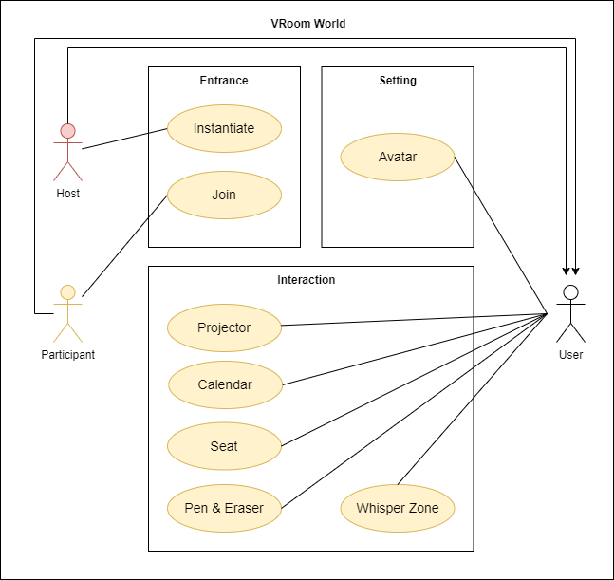

[Figure ] Use Case Diagram

* 1. Performance Requirements

This section describes the performance requirements of VRoom. This section is divided into two parts: Static numerical requirements and dynamic numerical requirements. Static numerical requirements cover items that are not related to time. On the other hand, dynamic numerical requirements cover items that are related to time. The following requirements are based on estimates and may be changed in the final application.

* + 1. Static Numerical Requirements
* The system management tool supports only one administrator
* The system supports only one simultaneous user for each device. The system does not support multiple connections on the same device. However, after disconnecting, user can switch accounts and access
* The system should run smoothly on devices with at least 4GB RAM and Intel® i5-4590 / AMD FX 8350 CPU. It requires a 64-bit processor and operating system, Windows 8.1 and Windows 10
  + 1. Dynamic Numerical Requirements
* The system runs smoothly for at least 100 simultaneous users. And the system can handle at least 1,000 active user accounts and profiles
* Each account must be activated within 10 seconds of linking
* The login process should be completed within 10 seconds
* Entering the meeting room world should be completed within 30 seconds
  1. Design Constraints

The system should contain only components that can be distributed under the MIT license.

The system must be designed to run on VRChat.

* 1. Standards Compliance

All programs in the system follow conventional programming techniques. We will use VRChat Udon which is a programming language built by the VRChat development team and follow their guidelines.

* + 1. Compliance for Submitting World
* Submit one world per user per seven days to Community Labs
* Update your world as often as you like
* If your world is already Public, you don't need to re-submit the world if you update it
* If your world or any content in the world violates the VRChat Terms of Service or the Community Guidelines, your ability to submit worlds to Community Labs will be suspended for a period of time
* Try to keep your worlds under 200MB
* Test your lighting
  + 1. Compliance for Performance
* Aim for greater than 45 FPS with a single VR user at the spawn
* Do not use shaders that are not VR-compatible
* Be very careful with post-processing effects
* Do not put more than 2 video players in a room
* Do not put more than 1 mirror in your room and make any and all mirrors in your world toggleable
* Do not overuse real time lights
  + 1. Compliance for General
* Do not use Blendfiles for import
* Test your world and test your world in VR
* Test your lighting
  1. Software System Characteristics

Software system characteristics are well understood through non-functional requirements. This section shows several non-functional requirements of the system. There are product requirements, organization requirements, and external requirements as follows.

* + 1. Product Requirements

Product Requirements describes the requirements that should be satisfied when the software is operating. Our system should satisfy following requirements.

* + - 1. Usability Requirements

Usability is one of the most important non-functional requirements of our system. The system should be easy to be used and should be organized in a way that user errors are minimized. Each user shall be able to use all the system functions instinctively. This means that user interface should be simple, instinctive, and easy to use.

* + - 1. Performance Requirements

The performance of a system depends on how quickly the system respond to user requests. For requests such as entering the meeting room, the system must be able to provide it up to 30 seconds.

* + - 1. Reliability Requirements

The system should provide its service at any given time. The meeting room should be able to be used by users at any time. Also, only allowed users must be able to enter the meeting room.

* + - 1. Security Requirements

The users should be properly authenticated before using the system. It should make sure that an unauthorized user cannot access the system. Also, only administrator can access every user’s confidential information such as user’s personal Information, ID, and password.

* + 1. Organizational Requirements

These requirements are derived from policies and procedures in the customer’s and developer’s organizations.

* + - 1. Operational Requirements

Users of the system shall identify themselves using their Steam account. The system provides a metaverse meeting room to people who usually don’t use it. Thus, it should be user-friendly interface. User would enter the meeting room within 1 minutes. The system works at any time when users need the meeting room.

* + 1. External Requirements

It describes all requirements that are derived from external environment of the system.

* + - 1. Safety / Security Requirements

The system should guarantee that the external system cannot access personal information. It must ensure to prevent user’s data without being lost.

* + - 1. Regulatory Requirements

The software must not infringe on open source licenses when using open source software. Also, the system should not violate user’s privacy according to national privacy standard.

* 1. Organizing the Specific Requirements

Different classes of systems need different organizations of requirements. There is no one optimal organization for all systems. We’ve organized the requirements by functional hierarchy. In this section, we’ll use Unified Modeling Language (UML) to show the relationships between the system components, the system and its environment.

* + 1. Class Model

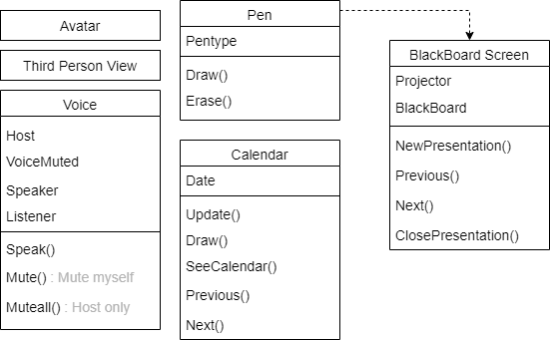

[Figure ] Class Model

* + 1. Object Model

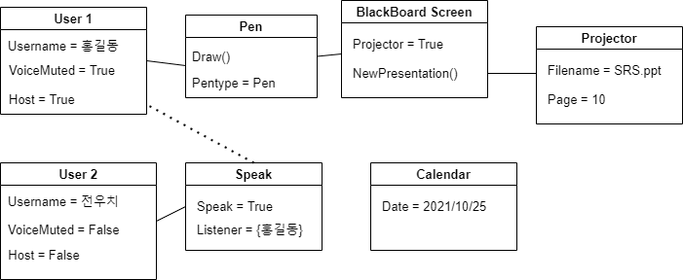

[Figure ] Object Model

* + 1. Interaction Model

See 3.2.2 Use Case diagram.

* + 1. Behavior Model
       1. Sequence Diagram

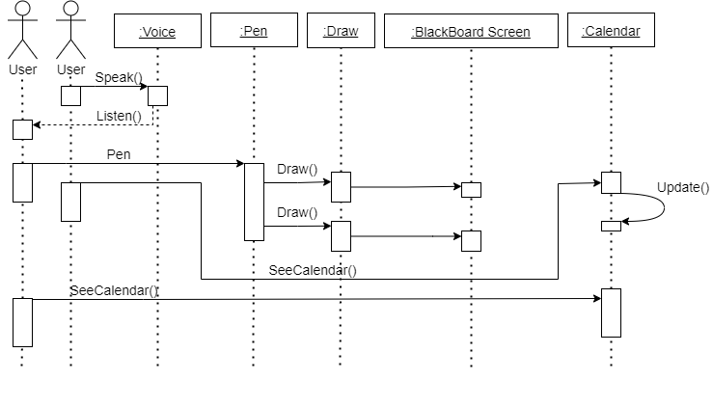

[Figure ] Sequence Diagram

* 1. System Architecture

In this section, we present a high-level overview of the anticipated system architecture, showing the distribution of functions across system modules. We use client-server pattern.

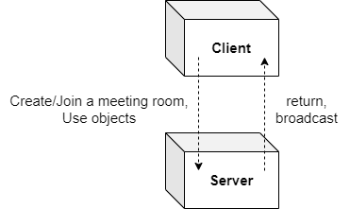

[Figure ] System Architecture

* 1. System Evolution

In this section, we’ll describe the fundamental assumptions on which the system is based and any anticipated changes due to hardware evolution, changing user needs, and etc. This section is useful for system designers as it may help them avoid design decisions that would constrain possible changes to the system.

* + 1. Limitation and Assumption

VRoom is only available in VRChat environments. In other words, all users must install Steam and VRChat. This makes communication only possible by voice chat, and typing is impossible. VRChat assumes that users use VR devices, however, ordinary users rarely have them. Thus, we assume that VRoom users only use desktop or laptop and have microphone and speaker devices.

* + 1. Evolutions of Hardware and Change of User Requirements

Recently, with the growing interest in metaverse, many people predicted that the VR market would grow together. In fact, however, the growth of VR is relatively slow compared to the interest in VR. It’s because VR hardware has not yet developed significantly. If these devices improve further and if many people use them, VRoom will also need to evolve accordingly.

Since we didn’t develop the motion-capturing actions that cannot be used in desktop or laptop, features corresponding to the body movement of the user should be added. For example, generate pens by waving your hand or call pamphlets by knocking the table.

1. Supporting Information
   1. Document History

[Table ] Document History

|  |  |  |  |
| --- | --- | --- | --- |
| **Date** | **Version** | **Description** | **Writer** |
| 2021. 10. 27. | 1.0 | Addition of 1 and 4 | Kim Hongbeen |
| 2021. 10. 27. | 1.1 | Addition of 2.1, 2.2 | Lee Jiwoo |
| 2021. 10. 27. | 1.2 | Addition of 2.3, 2.4, 2.5 | Kim Minhee |
| 2021. 10. 27. | 1.3 | Addition of 3.1 | Kim Jinwoong |
| 2021. 10. 27. | 1.4 | Addition of 3.2 | Hong Seongjun |
| 2021. 10. 27. | 1.5 | Addition of 3.3, 3.4, 3.5, 3.6 | Seo Chaeyeon |
| 2021. 10. 27. | 1.6 | Addition of 3.7, 3.8, 3.9 | Lee Hyewon |
| 2021. 10. 29. | 2.0 | Unification of terms | Kim Hongbeen |
| 2021. 10. 29. | 2.1 | Revision of 2.3, 2.4 | Kim Minhee |
| 2021. 10. 29. | 2.2 | Revision of 3.7 | Lee Hyewon |
| 2021. 10. 29. | 2.3 | Revision of 3.2 | Hong Seongjun |
| 2021. 10. 29. | 2.4 | Revision of 3.1 | Kim Jinwoong |
| 2021. 10. 29. | 2.5 | Revision of 3.4 | Seo Chaeyeon |
| 2021. 10. 30. | 2.6 | Revision of 1 | Kim Hongbeen |
| 2021. 10. 31. | 2.7 | Revision of 3.5 | Seo Chaeyeon |
| 2021. 10. 31. | 2.8 | Final | Kim Jinwoong |
| 2021. 11. 20 | 3.1 | Revision of 1 | Kim Hongbeen |
| 2021. 11. 20 | 3.2 | Revision of 2.1, 2.2 | Lee Jiwoo |
| 2021. 11. 20 | 3.3 | Revision of 3.2 | Hong Seongjun |